

APEC Experts Group on Illegal Logging and Associated Trade (EGILAT)

Timber legality guidance template for China
(February 2019)

The purpose of this guidance document is to provide APEC member economies with advice on timber legality on the laws and regulations in place in <China>. It arises from discussions at the 5th EGILAT meeting in Qingdao, China, in May 2014, where it was agreed it would be beneficial to compile an APEC compendium of timber legality guidance documents to support the legal timber trade between APEC members.
Contents
1 Overview of Timber Legality in China 3
2 Which laws regulate timber harvesting and exportation in China? 6
3 How do timber harvesting laws operate in China? 9
4 Licences, Permits and Certification Schemes 16
5 Legality of timber products manufactured in China 20
6 Other relevant non‐government resources 22
7 Who should I contact to get more information? 24
8 Appendices 25
Appendix 1: Timber Logging Permit (example) 26
Appendix 2: Timber Logging Permit (English translation) 27
Appendix 3: Timber Transport Certificate(example) 28
Appendix 4: Timber Transport Certificate (English translation) 29

Overview of Timber Legality in China
NOTE: This section should provide general information on forestry and the timber industry in China.
This section may include information that answers the following questions:
• Who owns forests in China (public, private, indigenous)?
• Are there forests in China with different statuses (protected, production)?
• Are there multiple jurisdictions for managing forests in China?
•Which bodies or institutions are responsible for managing and regulating forests in China?

Who owns forests in China (public, private, or indigenous)?
China’s forest resources are owned by the state, except those that are collectively owned according to the law. Certificates are issued to the following three forms of ownership of forests, trees and forestland, i.e. state ownership, collective ownership, and trees of individual ownership and forestland with individual use rights. Among them, forest ownership and forestland use rights can be transferred.
According to China’s eighth forest resources inventory, China’s forestland area is 310 million hectares (ha), among which 124 million ha are state owned, accounting for 40%, and 186 million ha are collectively owned, accounting for 60%. The forest area of China is 208 million ha, including 80.998 million ha of state-owned forests, around 39% of the total, 39.461 million ha of collectively owned, around 19%, and 87.229 million ha of individual ownership at, around 42%. The forest stocking volume is 18.137 billion m³, including 9.54 billion m³ for state-owned forests, accounting for 63%, 2.27 billion m³ for collectively owned forests, accounting for 15%, and 3.33 billion m³ for individually owned forests and forestland with individual use right, accounting for 22%.
Table 1 Ownership of Forest Resources in China
 | Ownership | Use rights
Forests | State , collective
Forestland | State, collective | individual
Trees | State, collective, individual

Are China’s forests in different states (protected, or used for production)?
According to the major functions of forests, China has divided forests into ecological forests and commercial forests. Ecological forests include protection forests and special-purpose forests. Commercial forests include timber forests, economic forests and fuelwood forests, as shown in the following table.
Table 2 Forests in China
Forest type | Area/proportion | Sub-type | Area/proportion | Stock volume /proportion
Ecological forests | 116 million ha, 56% | Protection forests | 99.67 million ha, 45.61% | 7.948 billion m³, 54%
Ecological forests | 116 million ha, 56% | Special-purpose forests | 16.31 million ha, 7.53% | 2.17 billion m³, 14%
Commercial forests | 89.58 million ha, 44% | Timber forests | 1.77 million ha, 35.17% | 4.602 billion m³, 31%
Commercial forests | 89.58 million ha, 44% | Economic forests | 20.56 million ha, 0.93% | Stock volume of economic forests not calculated
Commercial forests | 89.58 million ha, 44% | Fuelwood forests | 10.76% | 59 million m³, 1%

China’s forest management agencies
China’s forest management is under the jurisdiction of the State Forestry and Grassland Administration (SFGA). Its main responsibilities related to forest management include:
- Supervision and administration of forests and grassland and their ecological protection and restoration.
- Organization and oversight of ecological protection and restoration of forests and grassland as well as afforestation.
- Supervision and administration of forest, grassland and wetland resources.
- Supervision and administration of terrestrial wild fauna and flora.
- Supervision and administration of all types of natural protected areas.
- Promoting forestry and grassland related reforms.
- Formulation of policies related to optimal allocation of forest and grassland resources and timber utilization, relevant domestic forest industry standards and supervising their implementation, and supervision and guidance on forest products quality supervision.
- Providing guidance for the tackling of major illegal cases in the forest sector, supervising forest-related administrative law enforcement, and guiding the public security management in forested areas.
- Implementing integrated disaster prevention and mitigation plan related to forestry and grassland, developing forest and grassland fire prevention plan and standards and guiding their implementation, and guiding fire patrol, fire source management, and fire safety facilities.
- Oversight of forestry and grassland related science and technology, education and international cooperation, guiding talents development, conducting forestry and grassland related international cooperation and exchange and undertaking the implementation of RAMSAR, UNCCD and CITES etc..
Forestry and grassland authorities are also set up at province, city and county level to supervise, manage and conserve forest and grassland resources.

Which laws regulate timber harvesting and exportation in China?
NOTE: This section should provide a simple list of laws or regulations that regulate
Timber harvesting and exportation in China. These laws may include laws that:
• Authorise or regulate the harvesting or exportation of timber;
• Prohibit or regulate timber harvesting in specified locations, such as in parks, reserves,
or protected areas;
• Prohibit or regulate harvesting or exportation of specific tree species;
• Require any type of payment, such as royalties, stumpage, or other fees, for the
right to harvest timber;
• Grant legal rights of use and tenure in relation to the place in which timber is
harvested to people or groups of people, such as indigenous peoples;
• Prohibit or regulate the transportation, export, import, or transhipment of timber
or wood products;
• Regulate the possession, purchase, sale, or processing of timber or wood products;
and
• Otherwise must be complied with for timber or wood products to be considered
legally harvested or exported.
Please list and provide links to these laws and regulations.

The Chinese government has enacted laws and regulations on forest tenure, timber harvesting, timber transportation, and timber import and export and has established a series of management systems. Relevant laws or regulations are listed in the following table (including but not limited to):

Table 3 List of Relevant Laws and Regulations
Content | Law or regulation | Website link
Approving or regulating timber harvesting, forest tenure, timber transportation | Forest Law of the People’s Republic of China | http://english.forestry.gov.cn/index.php?option=com_content&view=article&id=307&catid=11&Itemid=111
 | Regulation on the Implementation of the Forest Law of the People's Republic of China | http://en.woodlegality.net/forest_laws/iitem_id710_a6y0vetcepdnxq8b4pl8cq8841446120308102.shtml
Approving or regulating timber import and export | Customs Law of the People’s Republic of China | http://english.customs.gov.cn/Statics/644dcaee-ca91-483a-86f4-bdc23695e3c3.html
Approving or regulating timber import and export | Foreign Trade Law of the People’s Republic of China | http://english.mofcom.gov.cn/article/policyrelease/Businessregulations/201303/20130300045871.shtml
Approving or regulating timber import and export | Regulation of the People’s Republic of China on the Administration of the Import and Export of Goods | http://www.mofcom.gov.cn/article/swfg/swfgbf/201101/20110107349108.shtml
Prohibiting or regulating logging in specific areas, such as parks, nature reserves or protected areas;  Prohibiting or regulating the harvesting or exporting of specific tree species;  Prohibiting or regulating the transport, export, import or re-export of timber or timber products; | Measures on the Administration of the Nature Reserves of Forest and Wild Animals | http://www.forestry.gov.cn/main/3950/20170314/459887.html
 | Regulations of the People’s Republic of China on Nature Reserves | http://english.mee.gov.cn/Resources/laws/regulations/Natural_Conservation_Biosafety/200711/t20071123_113364.shtml
 | Regulations of the People’s Republic of China on Scenic and Historic Areas | http://www.gov.cn/flfg/2006-09/29/content_402774.htm
 | Regulations of the People’s Republic of China on the Place of Origin of Import and Export Goods | http://www.gov.cn/zwgk/2005-05/23/content_240.htm
 | Regulations of the People’s Republic of China on Wild Plants Protection | http://www.moa.gov.cn/gk/zcfg/xzfg/200601/t20060120_539972.htm
 | Regulations of the People’s Republic of China on Administration of Import and Export of Endangered Wild Animals and Plants | http://www.gov.cn/zwgk/2006-05/17/content_282856.htm
Any forms of fees that must be paid for the right to harvest | Law of the People’s Republic of China on the Administration of Tax Collection | http://www.gov.cn/banshi/2005-08/31/content_146791.htm

How do timber harvesting laws operate in China?
NOTE: This section should provide information describing how China’s laws in the previous section operate, including the institutions in China that are responsible for managing and enforcing timber harvesting laws and regulations. This information will be important to inform trading partners about legal timber in China.
This section may include general information that answers the following questions:
• What are the requirements of legislation in China that authorises or regulates the
harvesting or exportation of timber?
• What are the requirements of the laws or regulations that prohibit or restrict
timber harvesting in specified locations, such as in parks, reserves, or protected areas;
• What are the requirements of the laws that prohibit or regulate harvesting or
exportation of specific tree species;
• What are the requirements of the laws that require any type of payment, such as
royalties, stumpage, or other fees, for the right to harvest timber;
• What are the requirements of the laws grant legal rights of use and tenure in
relation to the place in which timber is harvested to people or groups of people, such as indigenous peoples;
•What are the requirements of the laws that prohibit or regulate the transportation, export, import, or transhipment of timber or wood products;
•What are the requirements of the laws that regulate the possession, purchase, sale, or processing of timber or wood products; and
• What are the requirements of any other laws that must be complied with for
timber or wood products to be considered legally harvested or exported. Please
describe the requirements of these laws in such a way as to narrate the path that
legal timber takes from harvest to export, including the agencies and authorities
responsible for the relevant steps.

When harvesting, transporting, importing and exporting timber, relevant laws and regulations should be followed, such as the Forest Law of the People’s Republic of China, Regulation on the Implementation of the Forest Law of the People's Republic of China, Regulations on Plant Quarantine, Rules for Implementing the Regulations on Plant Quarantine (Forestry Part), Law of the People’s Republic of China on the Administration of Tax Collection, Notice of the Ministry of Finance and the State Administration of Taxation on the Exemption of Taxes on Agricultural Specialties for Enterprises Harvesting Logs from State-Owned Forest Areas, Notice of the Ministry of Finance and the State Administration of Taxation on Tax Policies for Enterprises and Organizations Implementing Natural Forest Protection Projects, and Regulations of the People’s Republic of China on Administration of Import and Export of Endangered Wild Animals and Plants. At present, China is working on amending the Forest Law of the People’s Republic of China.

3.1 How China regulates timber harvesting
3.1.1 Apply for a logging permit
According to the relevant provisions of Article 30 of the Regulation on the Implementation of the Forest Law of the People’s Republic of China, when applying for a logging permit, an applicant shall submit the certificate showing the ownership of the trees or the use right of the forestland, as well as other relevant supporting documents:
- State-owned forestry enterprises and public institutions shall submit the harvest plan and documents showing that regeneration on the logged areas has been completed in the previous year;
- Other organizations shall submit documents stating the purpose and location of logging, as well as forest type, forest condition, area, stocking volume, method, reforestation measures of the area to be logged, etc.;
- Individuals shall submit documents stating the logging location, area, tree species, number of trees, stocking volume, time for reforestation, etc.
3.1.2 Logging approval
According to Article 32 of the Regulation on the Implementation of the Forest Law of the People’s Republic of China, except otherwise clearly stipulated in the in the Forest Law, a logging permit could be issued by the following authorities:
- For county-level state-owned forest farms, the permit shall be issued by the competent forestry authority of the local county-level people’s government;
- For state-owned forestry enterprises and public institutions as well as other state-owned enterprises and public institutions at the levels of provinces, autonomous regions, municipalities directly under the central government, cities with district-level divisions, and autonomous prefectures, the permit shall be issued by the competent forestry authority of the local people’s government of the corresponding province, autonomous region, or municipality directly under the central government;
- For state-owned forestry enterprises and public institutions in key forest areas, the permit shall be issued by the competent forestry authority of the State Council.
3.1.3 Locations where timber harvesting is banned
According to the relevant provisions of Article 31 of the Forest Law of the People’s Republic of China, timber harvesting is banned in the following locations:
- For defense forests, seed production forests, environmental protection forests, and scenic forests, which fall under the category of protection forests and special-purpose forests, only logging for the purposes of forest tending and regeneration is allowed;
- Trees in scenic and historical sites as well as revolution memorial sites, nature reserves, and forests in tourist attractions, which belong to special-purpose forests, are strictly protected from harvesting.
3.1.4 Regulations prohibiting or restricting the export of trees, their products and derivatives
According to Article 38 of the Forest Law of the People’s Republic of China and the relevant provisions in the Convention on International Trade in Endangered Species of Wild Fauna and Flora (CITES) and the Regulations of the People’s Republic of China on Wild Plants Protection, it is prohibited or restricted to export precious and endangered trees as well as their products and derivatives. Specific provisions are as follows:
- Precious trees, their products and derivatives are prohibited or restricted by the state from exporting.
- In the case of exporting precious trees, their products and derivatives restricted from exporting, the exporter must have the endorsement from the competent forestry authority of the local people’s government of the corresponding province, autonomous region, or municipality directly under the central government, and report to the competent forestry authority of the State Council, i.e. NFGA, for approval. The customs will only grant access when seeing the approval documents from NFGA. Where the trees or their products and derivatives to be imported or exported are endangered species restricted from importing or exporting stated by the international conventions ratified by China, the importer or exporter must apply for the permit from the domestic endangered species import and export management authority. The customs will grant access when seeing the permit.
- China is a party to CITES, and prohibits and/or restricts harvesting or collecting the species listed in the CITES appendices.
- China has promulgated the Regulations of the People’s Republic of China on Wild Plants Protection, prohibiting and/or restricting the collection of the listed rare wild plants.

Timber transport regulation in China:
3.2.1 Application and issuance of a timber transport certificate
According to Article 36 of the Regulation on the Implementation of the Forest Law of the People’s Republic of China, the following documents shall be submitted for applying for a timber transport certificate:
- Logging permit or other documents showing the timber are from legal sources;
- Quarantine certificate;
- Other documents prescribed by the competent forestry authority of the people’s government of the corresponding province, autonomous region, or municipality directly under the central government.
After receiving the documents above that are valid, the competent forestry authority of the people’s government above county level shall issue the timber transport certificate within 3 working days.
3.2.2 Timber transport regulation
According to Article 37 of the Regulation on the Implementation of the Forest Law of the People’s Republic of China, approved by the people’s government of the corresponding province, autonomous region, or municipality directly under the central government, timber inspection stations are set up in a forested area. The station is responsible for inspecting timber transportation; if they find the timber is transported without credentials, they shall stop the transportation and may temporarily seize the timber and immediately report to the competent forestry authority of the people’s government above county level for penalty.
According to Articles 3, 7, 8, 9, and 10 of the Regulations on Plant Quarantine, and Articles 14 to 22 of the Rules for Implementing the Regulations on Plant Quarantine (Forestry Part), a phytosanitary certificate shall be available when applying for a timber transport certificate.
When transporting forest plants and their products subject to quarantine, a Phytosanitary Certificate (original copy) shall be handed over to the transportation authority or the postal department for shipment along with the cargo, and the consignee shall keep it for future reference. For plants and plant products received, the phytosanitary institution of the province, autonomous region, or municipality directly under the central government where the receiving party is located shall check the phytosanitary certificate and may re-examine the plants and their products if necessary.

Taxes, fees and usage fees
Entities engaged in timber harvesting, transportation and export shall comply with relevant laws and regulations, and timely provide relevant forestry departments and forestry management authorities with payment evidence of taxes, fees and usage fees. These include but are not limited to VAT and reforestation fees. In the timber supply chain, taxes / fees are required at different phases, which must be paid at the time of or before the issuance of official certificates and permits.
- Law of the People’s Republic of China on the Administration of Tax Collection (Articles 1, 2, and 4)
- VAT and other sales taxes: Law of the People’s Republic of China on the Administration of Tax Collection (Articles 1, 2, and 4); Notice of the Ministry of Finance and the State Administration of Taxation on the Exemption of Taxes on Agricultural Specialties for Enterprises Harvesting Logs from State-Owned Forest Areas; Notice of the Ministry of Finance and the State Administration of Taxation on Tax Policies for Enterprises and Organizations Implementing Natural Forest Protection Projects, requiring the following payments: 10% VAT on logs, and self-produced forest products sold by forestry producers are exempt from VAT; VAT rate for small-scale commercial enterprises is 4%; tax on special agricultural products: a 5% tax is temporarily charged from enterprises harvesting logs from state-owned forest areas in northeast China and Inner Mongolia.
- Income and profit tax: Law of the People’s Republic of China on the Administration of Tax Collection (Articles 1, 2, and 4), requiring to pay the corporate income tax.

Regulation of the import and export of timber and timber products in China:
3.4.1 Import management
The import management of timber and timber products in China can be divided into two categories, i.e. timber import management free from CITES control and timber import management under CITES control.
（1）Non-CITES controlled timber import management procedures:
Step 1: When the goods arrive at the port, the customs shall confirm the electronic warehouse receipt of the imported timber.
Step 2: When the goods are declared, the customs shall, depending on the transportation means and category of goods, use the risk control system to identify whether it is necessary to carry out boarding inspection or quarantine. The following documents shall be provided at the time of declaration:
- Certificate of origin from the exporting economy
- Phytosanitary certificate from the exporting economy
- Latin name
- Invoice
- Packing list
Step 3: After successful declaration and electronic payment of fees, taxes could be paid.
Step 4: After the goods are unloaded, the customs shall conduct risk assessment and inspection, and quarantine the unqualified goods.
Step 5: In the case of payment over the counter, after the customs declaration form is examined and approved, taxes shall be paid at the bank counter.
Step 6: The goods are granted access.
（2）CITES controlled timber import management procedures:
In addition to obeying the above non-CITES controlled timber management procedures, CITES controlled timber importer shall also apply for an import and export permit from the state endangered species import and export management office.
Step 1: The following materials shall be submitted:
- Export permit issued by the overseas regulatory body of CITES
- Import and export permit application form
- Import and export approval documents issued by the competent wildlife department of the State Council
- Import and export contract
- Identification documents
Step 2: After verifying the relevant materials, the state endangered species import and export management office or its branch office will issue the import and export permit.
Step 3: The importing enterprise submits the permit to the customs and other materials required.
Step 4: After verification, the customs will stamp on the customs declaration form as approval.
3.4.2 Export management
The export management of timber and timber products in China falls into timber export management free from CITES control and timber export management under CITES control.
（1）Non-CITES controlled timber export management procedures:
Step 1: Export inspection and quarantine shall be conducted at the place of production or the place of the consigner, which will be recorded electronically.
Step 2: The consigner of the exported goods shall declare at the customs 24 hours before the goods arrive at the customs supervision area and get loaded.
- Inspection and quarantine electronic record
- Invoice
- Export permit
- Processing trade manual (paper or electronic data) and other import and export related documents required by the customs.
Step 3: Based on the risk identification results, the customs will decide whether to conduct the inspection.
Step 4: The goods are released.
（2）CITES controlled timber export management procedures:
In addition to obeying the above non-CITES controlled timber management procedures, CITES controlled timber exporter shall also apply for an import and export permit from the state endangered species import and export management office.
Step 1: The following materials shall be submitted:
- Import and export permit application form
- Import and export approval documents issued by the competent wildlife department of the State Council
- Import and export contract
- Identification documents
- Where the wild animals and plants and their products are re-exported after import, the copy of the import and export permit endorsed by the customs and the copy of the customs declaration form for imported goods shall be submitted.
- Where the imported wild animal and plant raw materials are processed and then re-exported, the conversion plan and explanation of the relevant production and processing shall also be submitted.
- Where the wild animals and plants and their products are processed, imported and then re-exported, the processing trade manual (paper or electronic data) issued by the customs shall be submitted.
Step 2: After verifying the relevant materials, the state endangered species import and export management office or its branch office will issue the permit.
Step 3: The exporting enterprise submits the import and export permit to the customs and other materials required.
Step 4: After verification, the customs will stamp on the customs declaration form as approval.

Licences, Permits and Certification Schemes
NOTE: This section should provide general information on any requirements for
timber or wood products from China to have licenses, permits, or certifications.
APEC member economies will want access to information that can be used to reducethe risk that timber harvested in China has come from illegal sources. There may
be a variety of requirements for timber harvested in China to be considered legal.
These may include:
• An authority or permit to harvest or felling licence
• An authority or permit to transport, process or trade
• An export permit, issued by the relevant government authority
• A certification or a domestic legality verification system
•A non‐government certification (harvest or Chain of Custody) scheme recognised by China
Please list the ways that someone purchasing timber from China could reduce the risk that the timber products have come from illegal sources, including the agencies responsible for issuing any documentation. Suitable examples of documentation should be included at Appendix 1.

Legal timber certification in China
China has developed key measures to regulate the use of timber resources and to facilitate sustainable forest management in China. In order to achieve legal and sustainable use of forest resources, two certificates form the basis to manage China’s timber resources as follows:
4.1.1Timber Logging Permit (Appendices 1 and 2)
Article 32 of the Forest Law of the People’s Republic of China stipulates that a logging permit is mandatory for felling trees. The approval and issuing authority of a timber logging permit varies depending on the applying harvesting agency and its operating structure. The table below lists the detailed information on the authorities responsible for issuing timber logging permits in most cases in accordance with the provisions of the Forest Law.

Table 4 Issuing Authorities of Timber Logging Permits
Type of the harvesting organization | Issuing authority
State-owned forestry enterprises and public institutions, government agencies, associations, troops, schools and other state-owned enterprises and public institutions | Competent forestry authority above county level
Regeneration-oriented felling of railway and highway protection forests and urban forests | Relevant forestry authority of county-level or township-level people’s government
Rural collective entities | Competent forestry authority at county level
Rural residents who fell trees on their private hills and individually contracted collectively owned trees | Competent forestry authority at county level or a township-level people’s government entrusted by it

In addition, the Regulation on the Implementation of the Forest Law of the People’s Republic of China prescribes as follows:
- For county-level state-owned forest farms, the permit shall be issued by the competent forestry authority of the local county-level people’s government;
- For state-owned forestry enterprises and public institutions as well as other state-owned enterprises and public institutions at the levels of provinces, autonomous regions, municipalities directly under the central government, cities with district-level divisions, and autonomous prefectures, the permit shall be issued by the competent forestry authority of the local people’s government of the corresponding province, autonomous region, or municipality directly under the central government;
- For state-owned forestry enterprises and public institutions in key forest areas, the permit shall be issued by the competent forestry authority of the State Council.
When applying for a logging permit, an applicant shall submit the ownership certificate or the use right certificate of the woods concerned, as well as other relevant application documents:
- State-owned forestry enterprises and public institutions shall submit the harvest plan and documents showing that reforestation on the logged areas has been completed in the previous year;
- Other organizations shall submit documents stating the logging purpose, location, forest type, forest condition, area, stock volume, method, reforestation measures, etc.;
- Individuals shall submit documents stating the logging location, area, tree species, number of trees, stock volume, time for reforestation, etc.

4.1.2Timber Transport Certificate (Appendices 3 and 4)
Timber transport management is an important measure to regulate timber transport and prevent illegally harvested timber from entering circulation. Article 35 of the Regulation on the Implementation of the Forest Law of the People’s Republic of China stipulates that timber transported from a forest area, except those demanded to be distributed by the central government, must have a timber transport certificate issued by the competent forestry authority of the corresponding people’s government above county level. The timber transport certificate is valid from the place where the timber is transported to the destination and must be shipped along with the goods. Without a timber transport certificate, the carrier and individual shall not accept the timber for carriage.
The timber transport certificate applies to the following products: logs, sawn wood, bamboo and wood chips listed in domestic standards and industry standards, and other timbers prescribed by provinces, autonomous regions and municipalities.
The issuing authority of a timber transport certificate is: the competent forestry authority of the corresponding people’s government above county level.
To apply for a timber transport certificate, an applicant shall submit relevant supporting documents:
- Logging permit or other documents showing the timber are from legal sources;
- Quarantine certificate;
- Other documents prescribed by the competent forestry authority of the people’s government of the corresponding province, autonomous region, or municipality directly under the central government.
Timber inspection stations are set up in forested area approved by the people’s government of the corresponding province, autonomous region, or municipality directly under the central government. The stations are responsible for inspecting timber transport; if they find timber is transported without credentials, they shall stop the transport and may temporarily seize the timber and immediately report to the competent forestry authority of the people’s government above county level for penalty.

The above certificates and related documents, such as invoice or ledger that associate timber products with logging, can be used as evidence for the legality of the timber.

Certification or domestic legality verification system
The China Forest Certification Council (CFCC) is the main governing body of the China Forest Certification System (CFCS). The Secretariat is responsible for the daily operation. There are a technical committee and a dispute mediation committee.
CFCC is composed of members from government agencies, research institutes, higher education institutions, enterprises and non-profit organizations. Its main responsibilities include:
- Organize the drafting, validation and publishing of CFCS documents;
- Operate and manage CFCS;
- Deal with disputes, complaints and appeals related to CFCS;
- Promote and raise public awareness on CFCS;
- Participate in international exchanges and cooperation on behalf of CFCS.
CFCS was endorsed by the Program for the Endorsement of Forest Certification Schemes (PEFC) in 2014 and has been recognized by more than 40 countries. The scope of forest certification in China includes, among others, forest management, chain of custody, non-timber forest products, bamboo forests, forest eco-environment services, carbon sink forests, and precious and rare species for production and management. At present, CFCC has released two domestic standards including Forest Certification in China-Forest Management and Forest Certification in China-Chain of Custody as well as 23 industry standards such as Forest Certification in China-Non-timber Forest Products Management. Among them, the domestic standard on forest management certification covers 118 indicators, and the domestic standard for chain of custody adopts the PEFC standard for chain of custody of forest products.
According to the requirements of the Rules of Forest Certification, applicants shall put forward their request to a qualified certification body who will conduct conformity assessment in accordance with the procedures and the standards in the appendix of the Rules of Forest Certification.

Legality of timber products manufactured in China
NOTE: This section recognises that timber products from China may use timber inputs from numerous jurisdictions in manufactured products. APEC member economies will want access to information that can be used to assess and reduce the risk that timber in the manufactured products from China has come from illegal sources.
In preparing this section, please indicate:
•whether there are any arrangements, formal or otherwise, to trace timber supply chains in China;
•whether China has any legality assurance systems for domestic timber used in manufactured or complex products1;
•whether China has any legality assurance systems for imported timber used in manufactured or complex products.
Please list the ways that someone purchasing products with multiple timber inputs
from Chinacould reduce the risk that the timber products have come from illegal
sources, including the agencies responsible for issuing any documentation. Suitable examples of documentation should be included at Appendix A.

China Forest Certification System (CFCC/PEFC)-Chain of Custody (CoC)
CFCC/PEFC employs independent third-party certification audits to ensure that forest management activities meet the CFCC/PEFC social, economic and environmental sustainability criteria, and traces the wood raw materials contained in forest products through CoC audits. Correspondingly, for raw materials sourced overseas, forest product suppliers and processing enterprises will conduct PEFC certification of CoC or CoC certifications endorsed by PEFC, and put PEFC labels or labels endorsed by PEFC on the certified products to prove the source legality, traceability and sustainability of the timber raw materials and forest products.

China Forest Products Industry Association (CNFPIA) Association Standard-Timber Legality Certification in China
On August 1, 2017, the China Forest Products Industry Association (CNFPIA) released the standard of Timber Legality Certification in China. The standard stipulates the terms and definitions involved in timber legality certification, the principles for certifying enterprises’ timber source legality, the control method, and the certification logo, among others. The standard applies to forest management units, and timber processing and trading enterprises. For enterprises engaged in both forest management and timber processing and trade, all criteria of this standard shall be followed; for enterprises engaged only in timber processing or trade, the CoC timber legality standard shall be implemented.

Other relevant non‐government resources
NOTE: Please include in this section: any initiatives or government endorsed or supported entities or resources that assist in the identification of timber legality. Sources may include organisations, civil society groups or multilateral forums.

- Global Forest & Trade Network (China) (GFTN-China)
Established in 2005, the Global Forest & Trade Network (China) (GFTN-China) is a branch of GFTN in China (including Hong Kong and Taiwan). Forest products businesses in China that identifies the promotion of legal logging and sustainable forest management as their corporate development strategies can become members of GFTN-China. GFTN-China provides an important platform for its members to fulfill their commitment to responsible forest products manufacturing and raw materials procurement. In China and its timber and fibre supply countries, GFTN-China works to promote and improve the management of precious and threatened forests and curb illegal logging. GFTN-China encourages more enterprises who support legal timber trade to join it through a series of activities such as training, publicity, field assessment and market research.
http://www.wwfchina.org/programmedetail.php?id=39
- China Responsible Forest Product Trade and Investment Alliance (China RFA)
The China Responsible Forest Product Trade and Investment Alliance (China RFA) is founded by the Research Center for International Trade in Forest Products (CINFT) of the State Forestry and Grassland Administration (SFGA) with the support of relevant environmental protection organizations, international organizations, foundations, research institutes, associations, industry leading enterprises and financial organizations. China RFA supports the formulation of green trade policies, promotes the development of green forest product market, and builds a platform for exchanges and dialogues on responsible forest product trade. China RFA is governed by the Council made up of the initiating organizations, with its members being forest product enterprises that meet legal or sustainable and other green environmental standards. It is a non-profit and open alliance of responsible forestry enterprise members, and works closely with partners to build China’s responsible forest products forum and information center.
http://www.chinarfa.cn/
- China Paper Products Sustainable Development Initiative (CSPA)
The initiative was co-launched by the World Wide Fund for Nature (WWF) and the Chinese Forestry Industry Association (CFIA). The first group of businesses supporting CSPA covers 10 local and international enterprises in the whole paper and pulp supply chain, including China’s largest state-owned paper company, China Paper, and the largest private paper company, Sun Paper. It also includes internationally renowned enterprises such as Kimberly-Clark, International Paper, UPM, Stora Enso, Fibria, and HP, Fuji Xerox, and IKEA. The initiative requires member companies to produce and purchase responsible paper products through a series of measures to rapidly increase the supply of and demand for certified and recycled paper products. These measures include adopting traceable supply chain management to reduce illegally sourced fiber, using responsible forest management to conserve forest resources, raising consumer awareness of consuming certified and recycled paper products to stimulate the supply of and demand for credible certified fiber and recycled paper products among manufacturers and consumers, and building platforms to expand the market demand for Chinese responsible paper products worldwide. Therefore, responding to this initiative is an effective way for enterprises to demonstrate their responsible corporate development strategies to the public.
http://www.sh.xinhuanet.com/2015-09/15/c_134625890.htm

Who should I contact to get more information?
Note: This chapter shall provide government contact details for obtaining timber legality information.

For further information, please contact:
State Forestry and Grassland Administration of China
Email: CNIFT_NFGA@163.COM
Website: www.forestry.gov.cn

Appendices
Note: This chapter contains additional information, including relevant document samples, or links to websites that provide more information. Relevant document samples may include felling licence, logging permit, export permit, or government-approved legality certificates. Providing document samples will help APEC member economies, the private sector, and social groups understand the specific contents of the documents.
Appendix 1: Timber Logging Permit (English translation)
Appendix 2: Timber Logging Permit (example)
Appendix 3: Timber Transport Certificate (English translation)
Appendix 4: Timber Transport Certificate (example)

Appendix 1: Timber Logging Permit (example)
Timber Logging Permit
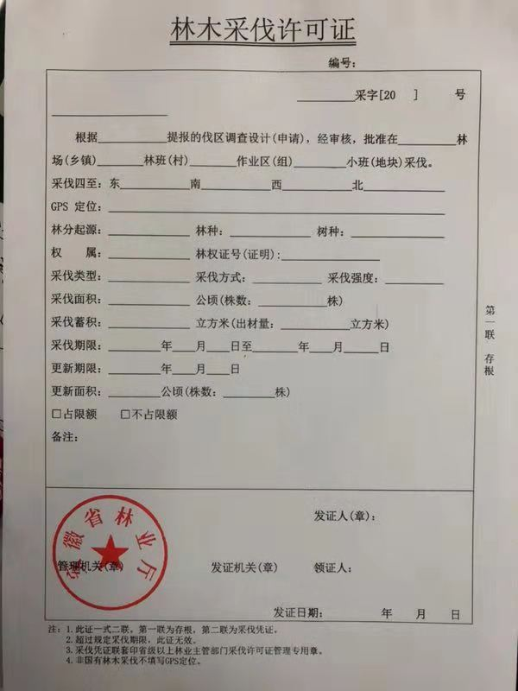

Appendix 2: Timber Logging Permit (English translation)
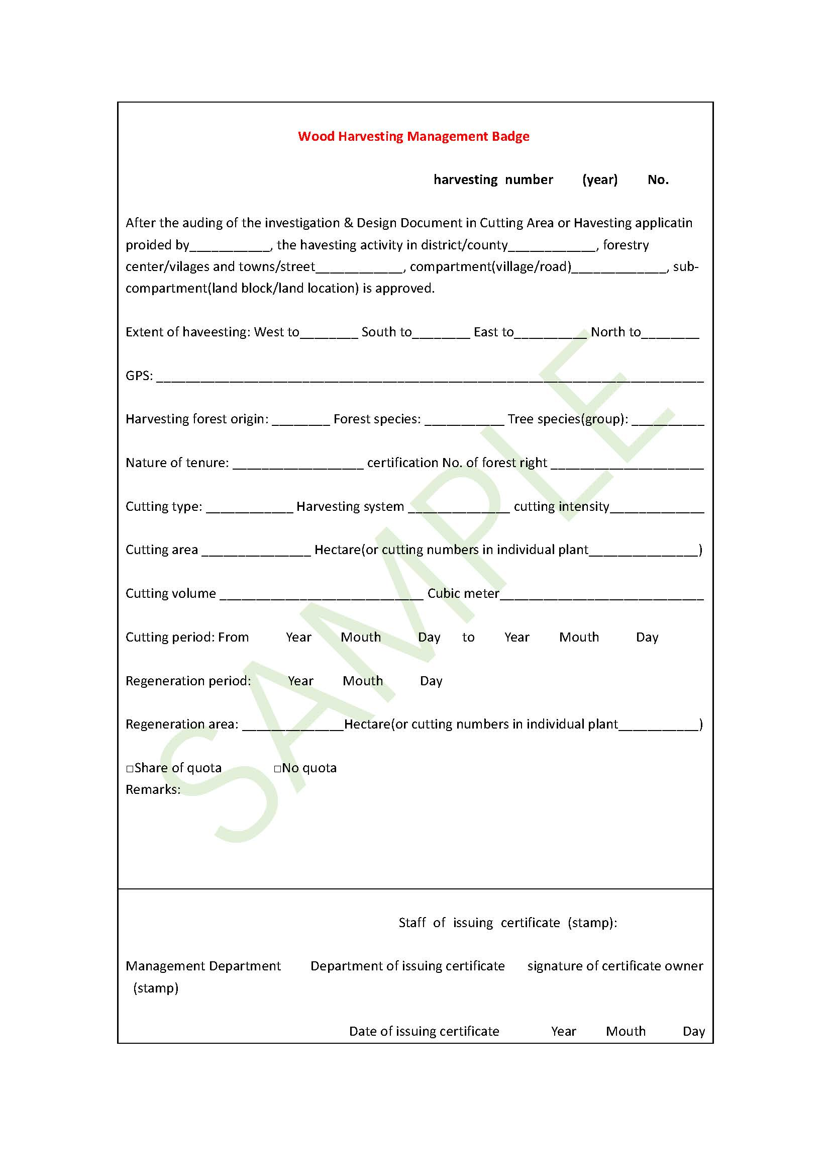

Appendix 3: Timber Transport Certificate(example)

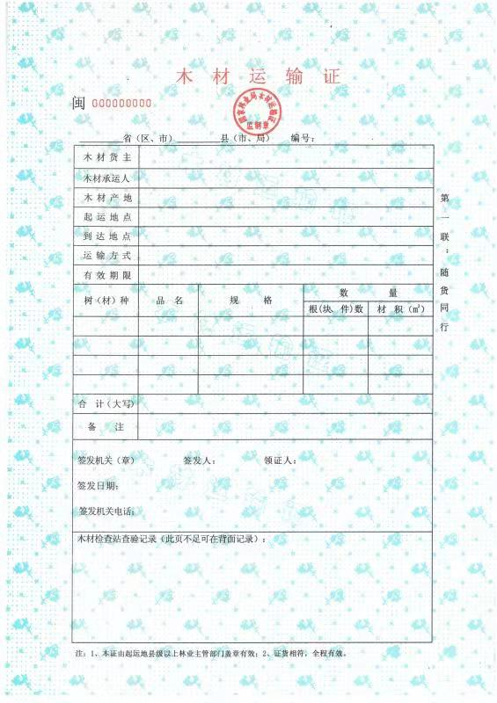

Appendix 4: Timber Transport Certificate (English translation)
